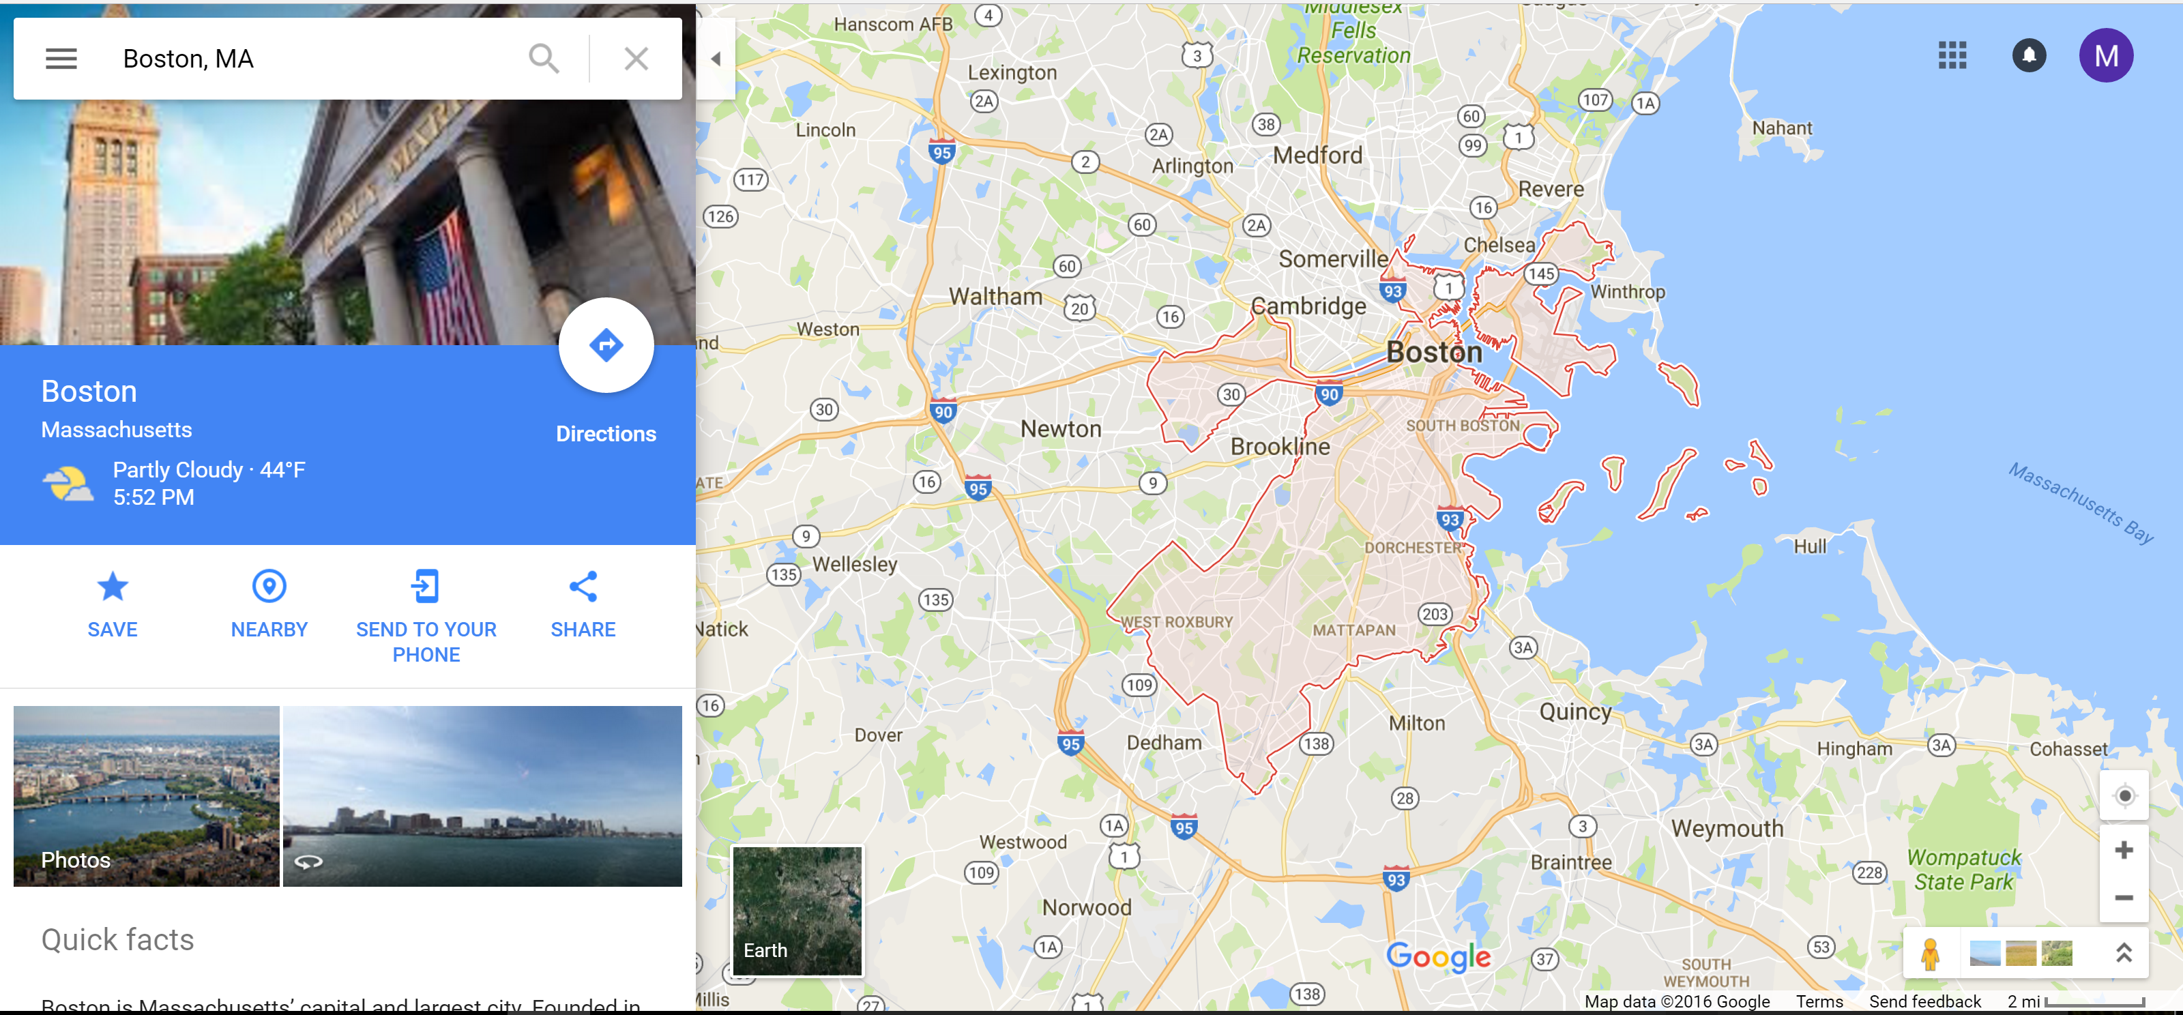

South boundary of boston

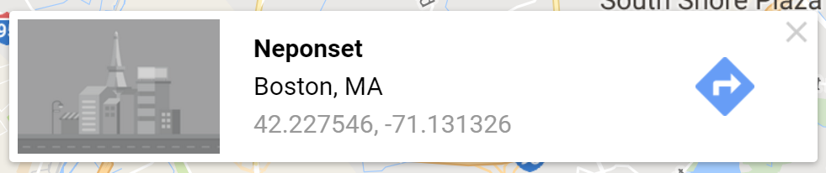

East boundary of boston



North boundary of boston

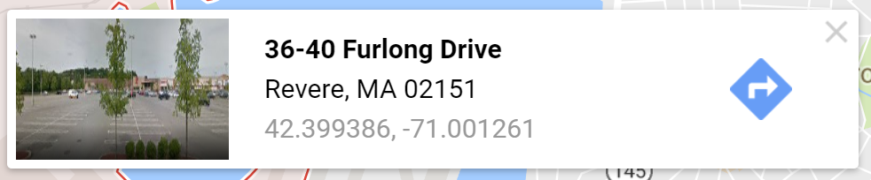

West boundary of boston

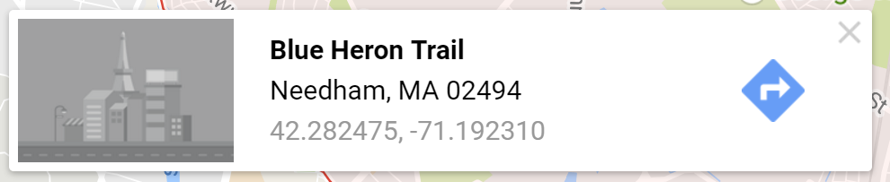

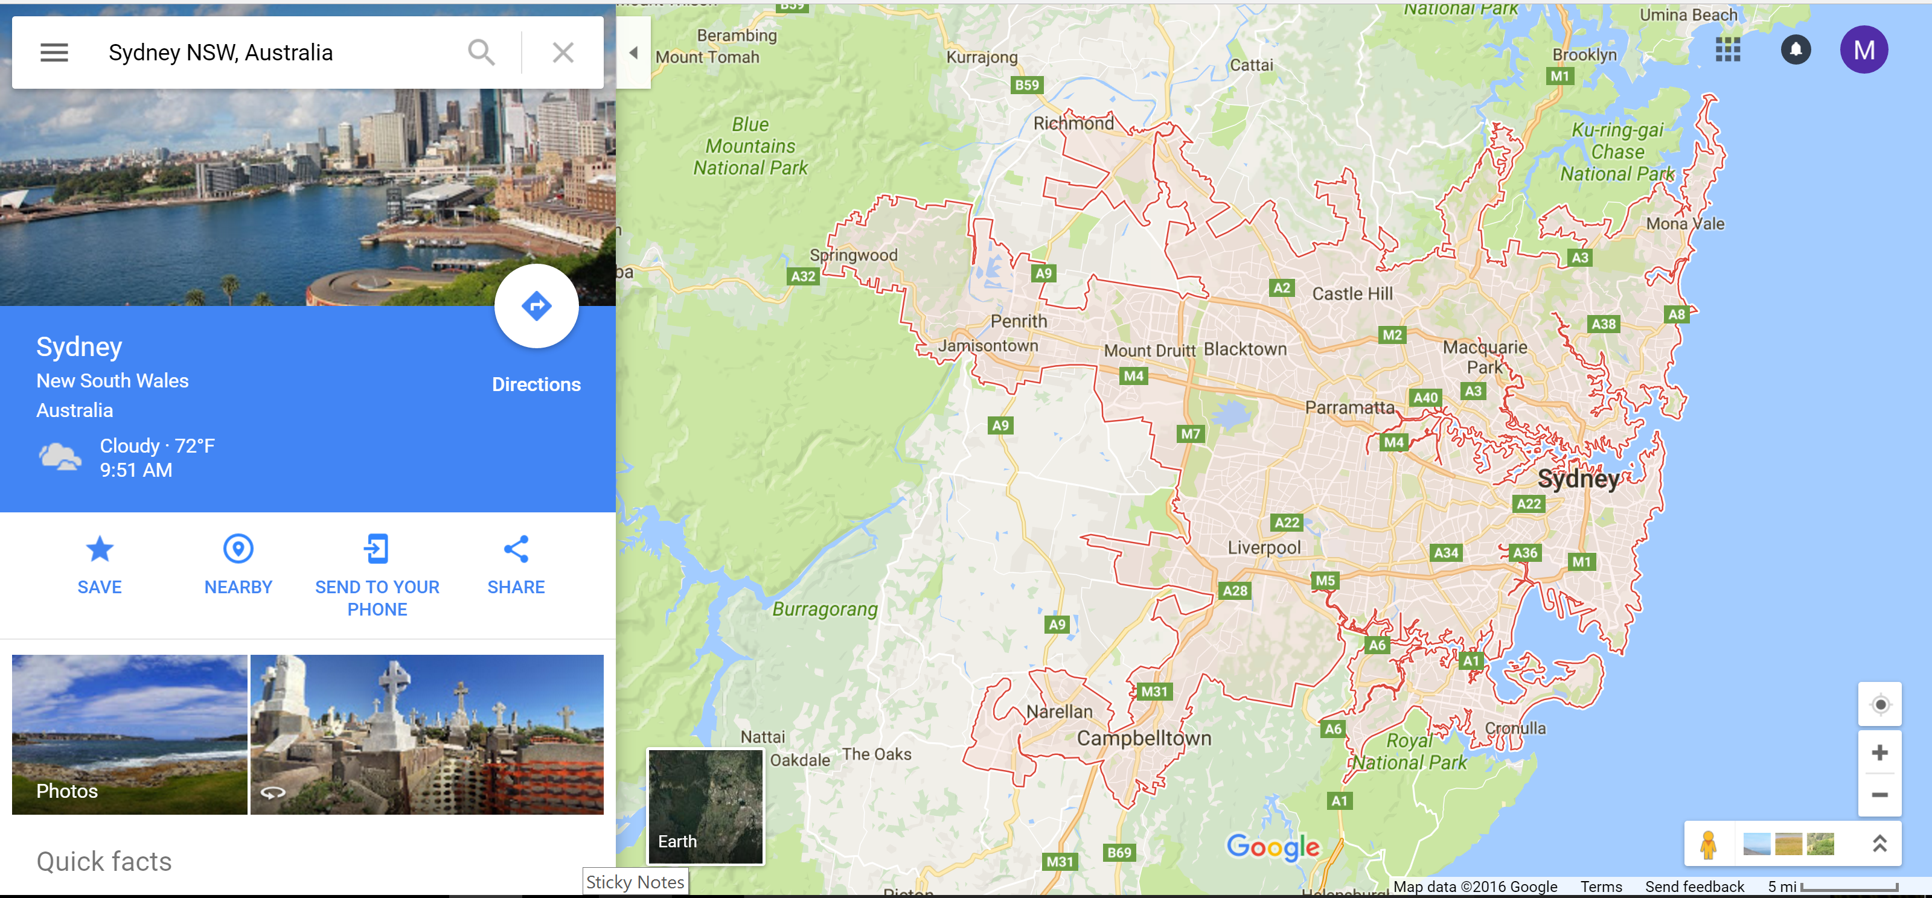

West boundary of Sydney:



South boundary of Sydney:



East boundary of Sydney:



North boundary of Sydney:



West boundary of the US eastern time zone:



NSW VIC TAS eastern timezone:

West



South



East



North



QLD Eastern Timezone

West

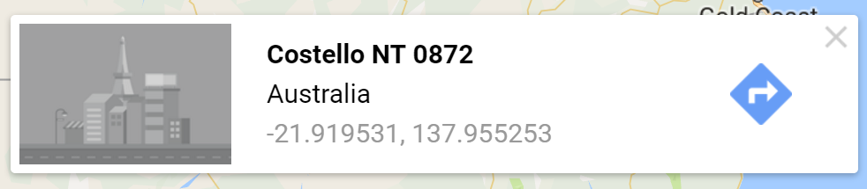

South



East



North

